Barley production over time compared to wheat

Sara Casimiro

Background

Research

Data Visualization

Conclusion

Works Cited (this will be on page two)

---

My plan is to use the XPath I began working on in class (also is the photo below) to find the production of barley over time, and then I will compare it to wheat. While my group hasn’t quite finished our group essay, this individual topic will relate to it by showing a comparison of the two grains. I'm hoping to find a significant difference between the two grains and to figure out why there is a difference. But unfortunately, I have not found the time yet to continue doing this research. I am also planning on using this format above to organize my project, and then I will translate it to markdown afterwards. This is also what we are doing with our group project as well.

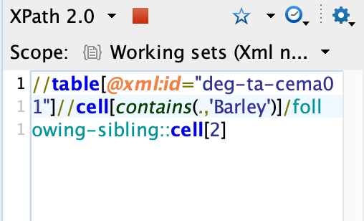

With this picture above, I'm going to add a “/measure” to it in order to get the right data. I still need to find a secondary source to get more information about barley during this time period. I'm so sorry for this very rough draft, it took me a long time to figure out what I wanted to do as an individual topic, so I don’t have a more completed version for you.